Steps to complete your DIGISKIL Digital Literacy Hands-on Exercise No. 1

Task 1: Create a Simple Document – 4 marks
• Open Microsoft Word and create a new document.
• Type your name, age, and a short introduction about yourself.
• Save the document with the name “MyFirstDoc” on your computer.
• Take the screenshot of the saved file.

Sample Screen-Shot:

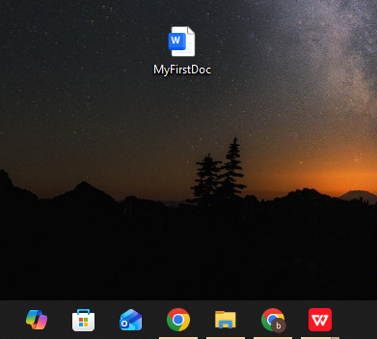

Task 2: Format the Text – 3marks
• Make your name bold.
• Change the font color of your age.
• Make the introduction italic.
• Take the screenshot.

Sample Screen-Shot:

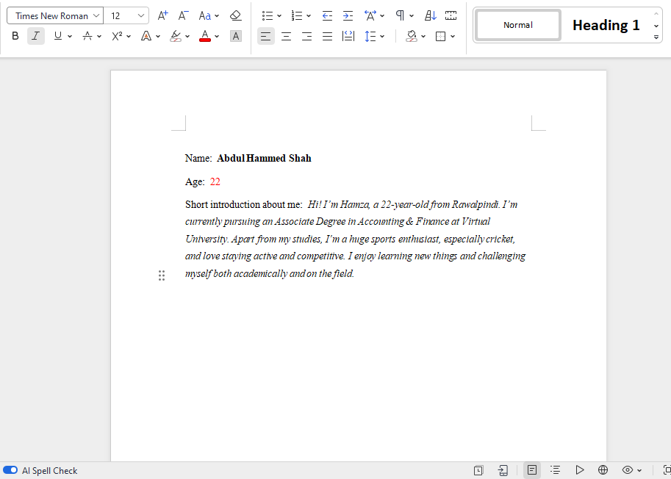

Task 3: Practice Safe Online Browsing – 3 marks
• Open a web browser and search for “Digital Literacy tips for beginners”.
• Find one tip and write it in a new Word document.
• Do not click on ads or unknown links.
• Take the screenshot and put it into the solution file.

Sample Screen-Shot:

